Copyright for test papers and marking guides remains with *West Australian Test Papers*.

The papers may only be reproduced within the purchasing school according to the advertised conditions of sale.

Test papers must be withdrawn after use and stored securely in the school until Friday June 15

**HUMAN BIOLOGY**

**Unit 1**

**2018**



Name: _______________________________________________________

Teacher: ___________________________________________________

**Time allowed for this paper**

Reading time before commencing work: ten minutes

Working time: three hours

**Materials required/recommended for this paper**

***To be provided by the supervisor***

This Question/Answer booklet

Multiple-choice answer sheet

***To be provided by the candidate***

* Standard items: pens (blue/black preferred), pencils (including coloured), sharpener,

correction fluid/tape, eraser, ruler, highlighters

* Special items: non-programmable calculators approved for use in this examination

**Important note to candidates**

No other items may be taken into the examination room. It is **your** responsibility to ensure that you do not have any unauthorised material. If you have any unauthorised material with you, hand it to the supervisor **before** reading any further.

**Structure of this paper**

|  |  |  |  |  |  |
| --- | --- | --- | --- | --- | --- |
| Section | Number of questions available | Number of questions to be answered | Suggested working time (minutes) | Marks  available | Percentage of examination |
| Section One  Multiple-choice | 30 | 30 | 40 | 30 | 30 |
| Section Two  Short answer | 9 | 9 | 90 | 100 | 50 |
| Section Three  Extended answer | 3 | 2 | 50 | 40 | 20 |
| **Total** | | | | | 100 |

**Instructions to candidates**

1. The rules for the conduct of the Western Australian external examinations are detailed in the *Year 12 Information Handbook 2018.* Sitting this examination implies that you agree to abide by these rules.

2. Answer the questions according to the following instructions.

Section One: Answer all questions on the separate Multiple-choice Answer Sheet provided. For each question, shade the box to indicate your answer. Use only a blue or black pen to shade the boxes. If you make a mistake, place a cross through that square, then shade your new answer. Do not erase or use correction fluid/tape. Marks will not be deducted for incorrect answers. No marks will be given if more than one answer is completed for any question.

Sections Two: Write your answers in this Question/Answer Booklet. Wherever possible, confine your answers to the line spaces provided.

Section Three: Consists of three questions. You must answer two questions. Tick the box next to the question you are answering. Write your answers in this Question/Answer booklet.

3. You must be careful to confine your responses to the specific questions asked and to follow any instructions that are specific to a particular question.

4. Supplementary pages for the use of planning or continuing an answer to a question have been provided at the end of this Question/Answer booklet. If you use these pages to continue an answer, indicate at the original answer where the answer is continued, i.e. give the page number.

**Section One: Multiple-choice 30% (30 Marks)**

This section has **30** questions. Answer **all** questions on the separate Multiple-choice Answer Sheet provided. For each question shade the box to indicate your answer. Use only a blue or black pen to shade the boxes. If you make a mistake, place a cross through that square, do not erase or use correction fluid, and shade your new answer. Marks will not be deducted for incorrect answers. No marks will be given if more than one answer is completed for any question.

Suggested working time: 40 minutes.

1. Which one of the following statements is **incorrect** about systematic errors? These are
   1. unpredictable errors that can occur in all experiments.
   2. errors that cannot be reduced by averaging.
   3. errors that can only be eliminated by changing the experiment procedure.
   4. errors that occur because of the way in which an experiment is designed.

Question 2 refers to the diagram of a mammalian leucocyte shown below.

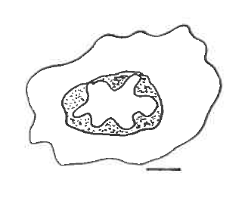

nucleus

1.5 µm

1. In the image of a mammalian leucocyte, the scale bar as shown represents 1.5 µm.

The maximum diameter of the nucleus of the leucocyte as shown is

* 1. 8.0 mm
  2. 36 mm
  3. 4.5 µm
  4. 9.0 µm

1. A potato tissue sample weighed 14.5 g at the start of an osmosis experiment and at the end it weighed 10.73 g. The percentage change is
   1. 26%
   2. -26%
   3. -35%
   4. 35%
2. Which of the following tissues may be found in the skin?
   1. epithelial tissue
   2. connective tissue
   3. smooth muscle
   4. all the above
3. The last section of the small intestine is the
   1. ileum.
   2. caecum.
   3. duodenum.
   4. colon.
4. Which one of the following bones is **not** part of the axial skeleton?
   1. skull
   2. ribs
   3. clavicle
   4. vertebrae
5. Which of the following does **not** cause lymph to flow through lymph vessels?
   1. involuntary contraction of skeletal muscles
   2. intestinal peristalsis
   3. ventricular filling
   4. gravity
6. White blood cells are produced in
   1. red bone marrow only.
   2. red bone marrow and in the liver.
   3. red bone marrow, in the liver and the lymph nodes.
   4. red bone marrow and in the lymph nodes.
7. Below is a list of structures that muscular tissue contain:
8. muscle fibre
9. myofibrils
10. myofilaments
11. muscle

The correct order of these structures from the largest to the smallest is

* 1. iv – i – ii – iii
  2. iv – ii – iii – i
  3. iv – i – iii – ii
  4. iv – iii – ii – i

1. A person with Type A **⁻** (A negative) blood will have
   1. TypeA antigens on the red blood cells.
   2. Type A plasma antibodies.
   3. Rh antigens on the red blood cells.
   4. none of the above.
2. A man that has blood type A is involved in a serious work accident and he needs to undergo an emergency blood transfusion. Which donor blood type(s) could this man receive?
   1. A only
   2. A and AB
   3. A, AB and O
   4. A and O
3. All the mechanisms below assist in returning venous blood to the heart **except**
   1. valves inside the veins.
   2. increasing the heart rate.
   3. pressure changes in the abdomen and thorax cavities due to breathing.
   4. contraction of skeletal muscles in the legs.
4. Which one of the following statements about the cardiac cycle is **incorrect**?
   1. When the atria contract, the semi-lunar valves open.
   2. When the atria contract, the atrioventricular valves open.
   3. When the ventricles relax, the semi-lunar valves close.
   4. When the ventricles contract, the atrioventricular valves close.
5. Most of the respiratory tract is lined with the ciliated epithelium except for the
   1. bronchi.
   2. bronchioles.
   3. trachea.
   4. alveoli.
6. During inhalation, as the intercostal muscles and the diaphragm __**i**___, the volume of the pleural cavity ___**ii**___, and air moves ___**iii**____ the lungs. Which of the following rows **correctly** indicates the effect of the change in intercostal muscles and the diaphragm on the volume of the pleural cavity and the movement of air when one inhales?

|  |  |  |  |
| --- | --- | --- | --- |
|  | **i** | **ii** | **iii** |
| (a) | contract | increases | into |
| (b) | contract | decreases | into |
| (c) | relax | increases | into |
| (d) | relax | increases | out of |

1. Gas transport in the blood takes places primarily with oxygen and carbon dioxide taking the form of A and B respectively. Which of the following best represents the primary way in which oxygen and carbon dioxide are transported in the blood?

|  |  |  |
| --- | --- | --- |
|  | **A** | **B** |
| (a) | oxyhaemoglobin | dissolved in plasma |
| (b) | oxyhaemoglobin | carbaminohaemoglobin |
| (c) | dissolved in plasma | carbaminohaemoglobin |
| (d) | oxyhaemoglobin | bicarbonate in plasma |

1. What do the enzymes – trypsin, pepsin and peptidase have in common?
   1. They are all enzymes produced by the pancreas.
   2. They are all involved in digestion of proteins.
   3. They are secreted and are active in the small intestines.
   4. They are secreted and are active in the stomach.
2. Carbohydrates, proteins and fats are all digested in different parts of the body. Which row in the following table shows where each of these three groups are **first** broken down?

|  |  |  |  |
| --- | --- | --- | --- |
|  | **carbohydrate** | **protein** | **fats** |
| (a) | mouth | duodenum | stomach |
| (b) | ileum | stomach | duodenum |
| (c) | stomach | mouth | ileum |
| (d) | mouth | stomach | duodenum |

1. Which answer below shows the correct order of the structures through which urine would travel through during urine formation and excretion?
   1. nephron, renal pelvis, urethra, bladder, ureter
   2. nephron, renal pelvis, ureter, bladder, urethra
   3. renal pelvis, ureter, nephron, urethra, bladder
   4. renal pelvis, nephron, ureter, bladder, urethra
2. Which of the following contributes mainly to the production of the glomerular filtrate?
   1. diffusion
   2. active transport
   3. glomerular capillary blood pressure
   4. facilitated diffusion
3. Which of the following best describes selective reabsorption in the kidney nephron?
   1. Active transport of Na⁺ from the proximal convoluted tubule cell towards a capillary.
   2. Facilitated transport of Na⁺ from the tubule lumen into the proximal convoluted tubule cell.
   3. Diffusion of water and plasma proteins from the proximal convoluted tubular cell towards a capillary.
   4. Diffusion of Na⁺ and Cl⁻ from the tubule lumen into the proximal convoluted tubule cell.
4. The arteriole leading out the glomerulus has a smaller diameter than the arteriole leading in because this
   1. raises the diffusion gradient so that more fluid is filtered into the blood.
   2. lowers the blood volume so that more fluid is filtered out of the blood.
   3. lowers the blood pressure so that more fluid is filtered into the blood.
   4. raises the blood pressure so that more fluid is filtered out of the blood.

Question 23 refers to the diagram of the joint and the associated movement between the   
 radius and carpal bone as shown below.

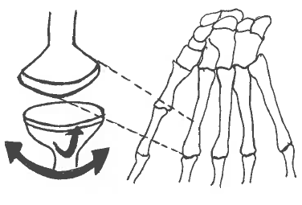

1. What is the name of the synovial joint that enables up and down and side to side movement, and is also found between the radius and the carpal bones?
   1. hinge
   2. condyloid
   3. ball-and-socket
   4. pivot
2. Which of the following statement is **incorrect** about synovial fluid? It
   1. contains phagocytic cells that remove micro-organisms and any debris.
   2. may decrease in volume when a joint is traumatised or injured.
   3. lubricates the joint and provide nourishment for the cells of the articular cartilage.
   4. forms a thin film over surfaces within the capsule.
3. A specific type of muscle will exhibit all of the following characteristics. Choose the best response.
4. have properties of contractibility, extensibility and elasticity.

ii. bring about movement of joints.

iii. give the body its form and contours.

iv. allow the body to maintain posture.

The specific type of muscle that exhibits all of the characteristics from above is known as

* 1. smooth muscle.
  2. voluntary muscle.
  3. skeletal muscle.
  4. cardiac muscle.

1. Deamination is a process that occurs in the liver with the use of enzymes. The reactants are shown in the incomplete word equation as follows.

enzymes

amino acid + oxygen products

The products of the deamination are

* 1. urea + water
  2. carbon dioxide + ammonia
  3. urea + ammonia
  4. carbohydrate + ammonia

1. Which of the following statements about mechanical and/or chemical digestions is **correct**?
   1. Mechanical digestion takes place in the mouth and small intestines only.
   2. Chemical digestion takes place in the mouth, stomach, small and large intestines.
   3. Mechanical and chemical digestions take place in the mouth, stomach and small intestines.
   4. Mechanical and chemical digestions take place in the mouth, oesophagus, stomach and small intestines.
2. Below is a list of several substances that are absorbed from the walls of the villi in the small intestines.
3. simple sugars
4. amino acids
5. water
6. water-soluble vitamins
7. fatty acids and glycerol

The substances that enter the lacteals of the villi are

* 1. i, ii, iii, iv and v
  2. i, ii and v
  3. i, ii
  4. v only

1. A group of Year 11 Human Biology students were given an investigation on enzyme activity. The investigation aims to determine the optimum pH for a series of enzymes - catalase, trypsin, amylase and lactase. The number of independent variables required for this type of investigation is
   1. 1
   2. 2
   3. 4
   4. 8
2. An investigation needs to satisfy ethical standards before it is conducted. Which of the following is **not** considered an ethical principle?
   1. anonymity
   2. informed consent
   3. personal preferences
   4. confidentiality

**End of Section One**

**Section Two: Short answer 50% (100 Marks)**

This section has **nine (9)** questions. Answer **all** questions. Write your answers in the spaces provided.

Supplementary pages for the use of planning/continuing your answer to a question have been provided at the end of this Question/Answer booklet. If you use these pages to continue an answer, indicate the original answer where the answer is continued, i.e. give the page number.

Suggested working time: 90 minutes.

**Question 31 (10 marks)**

The following question refers to the diagram of the plasma membrane shown below.

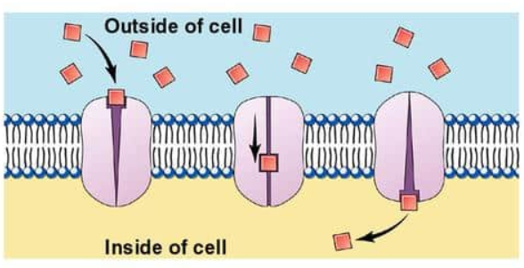

**Figure 1 Plasma membrane**

1. Identify the type of membrane transport shown in the diagram above. (1 mark)

________________________________________________________________________

1. Name **one** substance that is transported using the type of membrane transport identified in part (a). (1 mark)

______________________________________________________________________

1. State a location in the human body that this mode of membrane transport is most likely to take place. (1 mark)

_________________________________________________________________________

1. State **two** characteristics of carrier-mediated transport in the cell membrane. (2 marks)

__________________________________________________________________________________________________________________________________________________

1. State why a small lipid-soluble molecule will diffuse more quickly into a cell than a large, soluble molecule. (1 mark)

_________________________________________________________________________

_________________________________________________________________________

Some bacterial cells were placed in a solution containing two different solutes, A and B. The solution contained 8 mg/L of each solute. Both bacterial cells did not contain any of the solutes A or B at the start of the experiment. The concentration of the solutes A and B inside the cells were measured regularly over a period of 2 hours. The results were plotted on a graph as shown below.

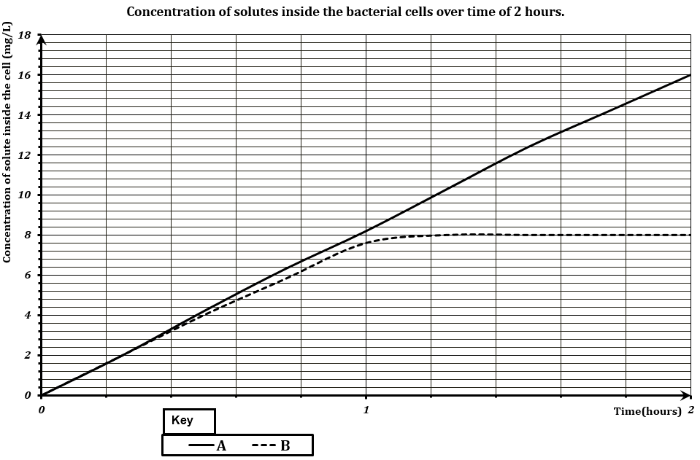

**Figure 2**

1. **Describe the two transportation processes used by solute A and B to enter the bacterial cells. Justify your answers using information from the graph above. (4 marks)**

_________________________________________________________________________

_________________________________________________________________________

__________________________________________________________________________________________________________________________________________________

**Question 32 (12 marks)**

1. Using a fully annotated diagram in the space below, demonstrate the lock and key model for an enzyme reaction.

(4 marks)

1. Why is an enzyme described as being “substrate-specific”? (1 mark)

__________________________________________________________________________________________________________________________________________________

1. How does an enzyme act as a catalyst for reactions? (1 mark)

_________________________________________________________________________

_________________________________________________________________________

Enzymes are necessary for chemical reactions to occur at a rate that can support biological

life. The following graph shows the initial rate of reaction of the enzyme

fluoroacetate dehalogenase (FAcD) as it converts substrates into products, glycolate and a

halogen, as substrate concentration is increased over a period of an hour.

**Initial rate of reaction with increasing substrate concentration**

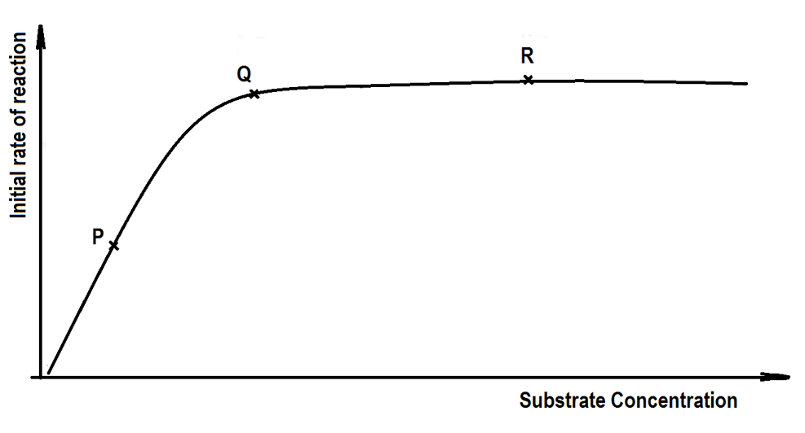

**Figure 3**

1. Using the terms `**active site’**, **`rate of reaction’**, `**substrate’** and `**enzyme’** molecules, explain what has happened at point P, Q and R. (6 marks)
2. P

___________________________________________________________________

___________________________________________________________________

(ii) Q

___________________________________________________________________

__________________________________________________________________

1. R

___________________________________________________________________

___________________________________________________________________

**Question 33 (13 marks)**

1. The muscles of the body are composed of muscle bundles, and each bundle contains a large number of muscle fibres. State how the structure of the muscle is suited to its function.

(1 mark)

__________________________________________________________________________________________________________________________________________________

1. Draw an annotated diagram of the sliding filament model and explain how muscle contraction takes place using this model. (7 marks)

________________________________________________________________________

________________________________________________________________________

________________________________________________________________________

________________________________________________________________________

________________________________________________________________________

1. Name and describe a muscular **or** a skeletal condition that occurs due to ageing. (2 marks)

_________________________________________________________________________

_________________________________________________________________________

_________________________________________________________________________

1. State **one** common treatment used to prevent the onset of this named condition in part (c).

(1 mark)

_________________________________________________________________________

Please read the following paragraph carefully to answer question (e).

**Use of Personal Devices in Diagnosis and Treatment**

The rise of increasingly sophisticated personal devices such as the iPhones and Fitbits means scientists can access information across all aspects of our daily lives. This information provided to scientists will give us a better insight than ever before into how and when we get sick. At the forefront of this research is the Centre for Big Data Research in Health (CBDRH), at Australia’s University of New South Wales. This research centre is using an array of personal devices to find new ways of diagnosing and treating health diseases. “Smartphones now come with very sensitive accelerometers that can pick up the slightest tap or jiggle, so they are good devices to measure any type of body movement,” says Dr Timothy Churches, a data scientist at CBDRH and the Ingham Institute in Sydney. Australian scientists are currently looking at using smartphones to characterise the gaits of patients after surgery, and using machine learning methods to try and detect changes that could occur in patients suffering from musculo-skeletal dysfunctions.

Adapted from Cosmos Magazine 9 Oct 2017

1. Comment on how the use of smartphones can be used to improve practices for the management and prevention of the condition identified in parts (c) and (d). (2 marks)

__________________________________________________________________________________________________________________________________________________

_________________________________________________________________________

_________________________________________________________________________

**Question 34 (5 marks)**

1. Name the location in the cell where each of these processes below occur. (3 marks)

|  |  |
| --- | --- |
| **Process** | **Location in the cell** |
| Glycolysis |  |
| Krebs Cycle  (citric acid cycle) |  |
| Electron transport chain |  |

1. Explain why the mitochondria are described as the `power house’ of the cell.

(2 marks)

_____________________________________________________________________

_____________________________________________________________________

**Question 35 (10 marks)**

The following question refer to the diagram of the human digestive system shown below.

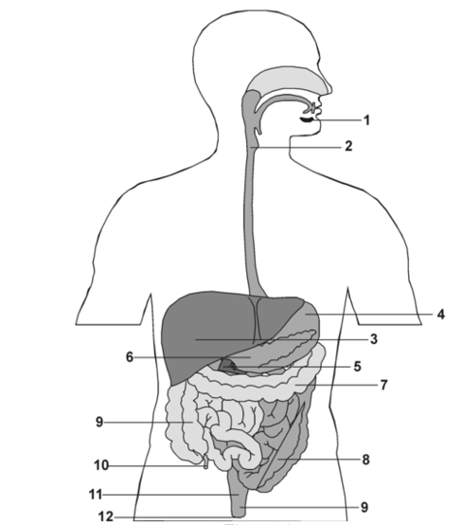

**Figure 4 Human Digestive System**

1. A slide has been taken from the longitudinal section of the tissue located in position **2,** showing the mucosa and muscle layers of this tissue.

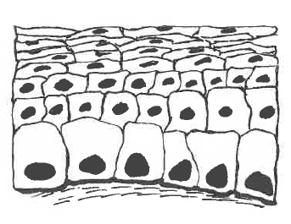

**Figure 5 Longitudinal section of tissue**

1. Identify the type of cell in Figure 5 and state a function of these cells. (2 marks)

___________________________________________________________________

___________________________________________________________________

The diagram below show the muscle layers that are located also at location 2

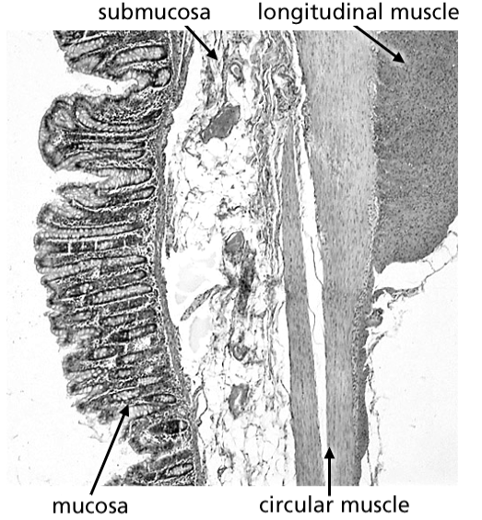

**Figure 6 Muscular tissue**

(ii) As shown above, the muscle is arranged into both circular and longitudinal

directions. State why this muscle arrangement is necessary at location 2**.** (1 mark)

___________________________________________________________________

___________________________________________________________________

(iii)State **two** other locations from Figure 4: Human Digestive System that would

share the same function as this muscle arrangement. (1 mark)

___________________________________________________________________

1. State **two** structural similarities and **one** difference between locations 2 and 8. (3 marks)

_________________________________________________________________________

__________________________________________________________________________________________________________________________________________________

1. State **two** main functions of the colon.

(2 marks)

_________________________________________________________________________

_________________________________________________________________________

1. Unlike the rest of the human digestive system, the stomach has an oblique muscle layer in addition. State how this facilitates its function. (1 mark)

_________________________________________________________________________

_________________________________________________________________________

**Question 36 (14 marks)**

The heart is a muscular organ that lies in the thoracic cavity behind the sternum. It has four chambers and these are connected to large blood vessels that carry blood towards and away from the heart.

1. Name the blood vessel associated with the heart that matches the appropriate description in the table below.

(4 marks)

|  |  |
| --- | --- |
| **Description** | **Blood vessel** |
| It supplies the heart muscle with oxygenated blood |  |
| It has the highest blood pressure |  |
| It carries oxygenated blood to the heart |  |
| It joins the ventricles of the heart to the capillaries of the lungs |  |

1. State **two** advantages of the double circulation found in the human body. (2 marks)

_________________________________________________________________________

__________________________________________________________________________________________________________________________________________________

1. Explain why it is important to prevent mixing of the blood in the two sides of the heart.

(2 marks)

_________________________________________________________________________

__________________________________________________________________________________________________________________________________________________

Question 36(d) refers to the graph below which shows the rate of blood flow from and to

the heart through a variety of blood vessels.

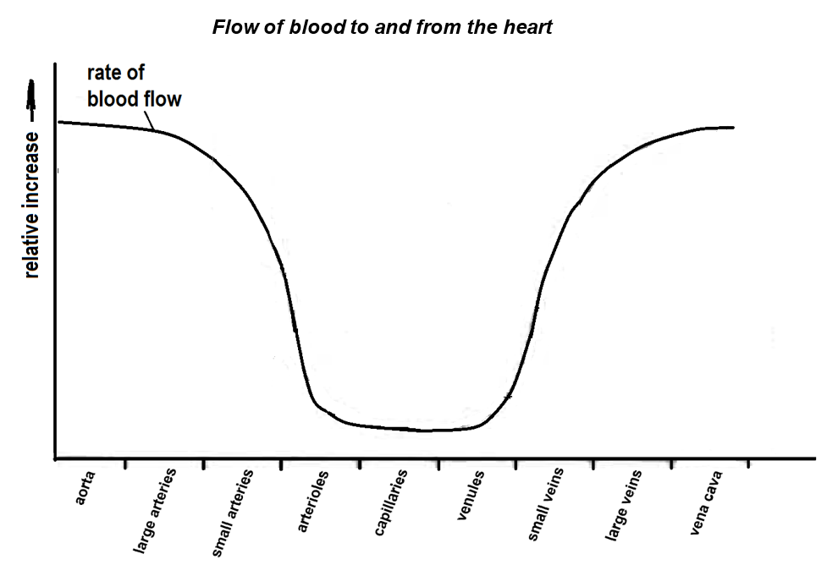

**Figure 7**

1. Describe **three** changes in the rate of blood flow as blood passes from the aorta to the vena cava. (3 marks)

____________________________________________________________________

____________________________________________________________________

____________________________________________________________________

1. On the graph above, draw a dotted line to show how the total cross-sectional area varies from the aorta to the vena cava. (1 mark)

1. On the graph above, draw a solid line to show how blood pressure varies from the aorta to the vena cava. (1 mark)
2. State **one** feature of the capillaries that increases the efficiency of metabolic materials exchange. (1 mark)

____________________________________________________________________

____________________________________________________________________

**Question 37 (16 marks)**

There are a number of factors that separately increase the risk of an individual suffering from cardiovascular disease. When combined together, the overall risk can be greatly amplified. An investigation was conducted to show the effect of three risk factors; namely, smoking, high blood pressure and blood cholesterol on the chance of heart attack in Australian men.

Category A refers to men who are heavy smokers and have high blood pressure.

Category B refers to men who are non-smokers and have high blood pressure.

Category C refers to men who are heavy smokers and have low blood pressure.

Category D refers to men who are non-smokers and have low blood pressure.

Data was collected from these four categories of men from a sample size of 1200 men. The percentage of these men suffering from a heart attack in a 5-year-period had a range of blood cholesterol levels varying from 5 mmol/L to 8 mmol/L. This information was recorded by a team of medical researchers at the University of Western Australia and the Royal Perth Hospital.

|  |  |  |  |  |
| --- | --- | --- | --- | --- |
| Blood cholesterol level  (mmol/L) | Percentage of men suffering from heart attack (%) | | | |
| Category A | Category B | Category C | Category D |
| 5.0 | 9 | 5 | 4 | 3 |
| 6.0 | 12 | 8 | 6 | 4 |
| 7.0 | 18 | 14 | 9 | 7 |
| 8.0 | 28 | 20 | 15 | 11 |

1. List **two** variables that should be controlled in the experiment. (2 marks)

__________________________________________________________________

__________________________________________________________________

1. Graph the results from the table on the grid provided. (6 marks)

A spare grid is provided at the end of this Question/Answer booklet. If you need to use

it, cross out this attempt.

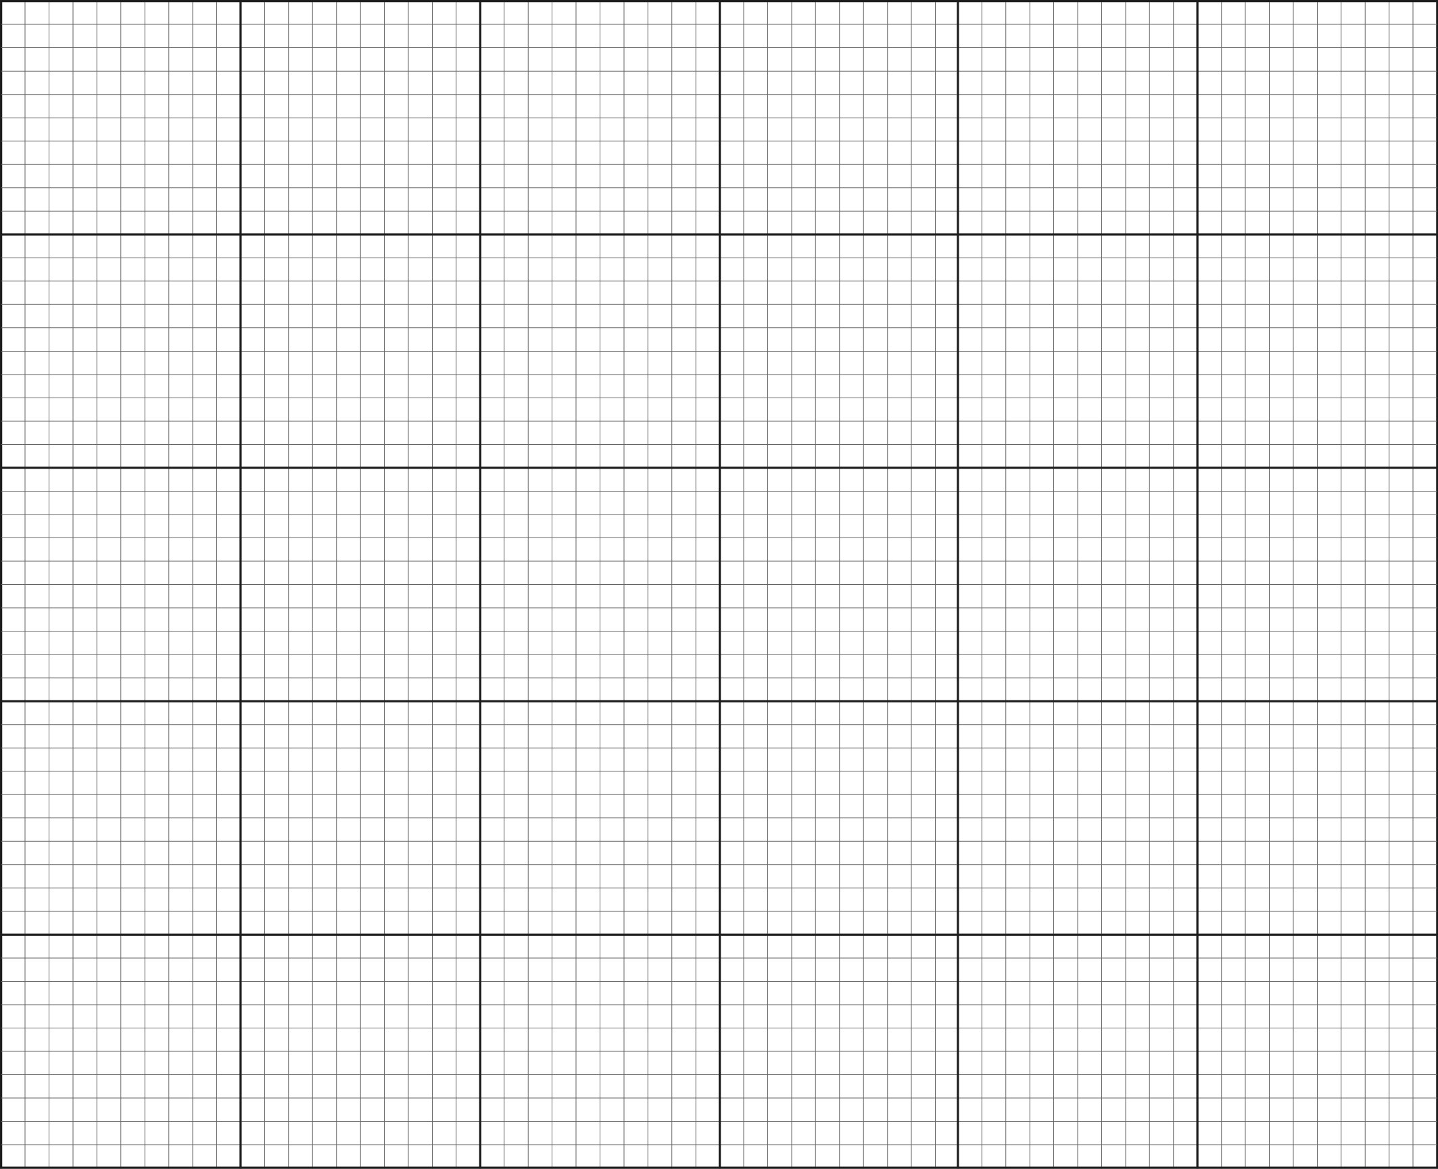

1. A smoker who has high blood pressure would like to reduce his risk of heart attack. If he could only change one risk factor, would he be better to give up smoking or to try reducing his blood pressure? With reference to your plotted graph, give a reason for your answer.

(2 marks)

_________________________________________________________________________

_________________________________________________________________________

1. A non-smoker with high blood pressure has a blood cholesterol of 5 mmol/L. Over a period of three years, his blood pressure increases to 8 mmol/L. According to the graph, calculate how many times greater his risk of heart disease is. Show your working.

(2 marks)

__________________________________________________________________________________________________________________________________________________

1. Two non-smoking men with low blood pressure both have a blood cholesterol level of 5 mmol/L. One of the men starts smoking and the other man’s blood cholesterol level increases to 7 mmol/L. Which one of the two men is now at greater risk of suffering a heart attack? Explain your answer referring to data in the graph. (2 marks)

_________________________________________________________________________

_________________________________________________________________________

1. Identify **two** components of a person’s diet that may contribute to an increase in the risk of heart disease.

(2 marks)

_________________________________________________________________________

_________________________________________________________________________

**Question 38 (10 marks)**

The following questions refer to the diagram below showing a kidney nephron.

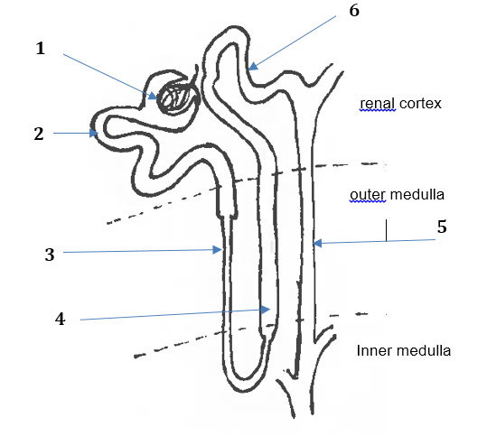

**Figure 8 Kidney nephron**

1. Match each of the processes (identified on the diagram with numbers 1 – 7) to the correct description of the process. Write the process number next to the correct description in the first column. Identify **one** substance passing through during this process in the last column where substances passing through are **not** given.

(8 marks)

|  |  |  |
| --- | --- | --- |
| **Process number** | **Description of the process** | **Substances passing through** |
|  | Filtration through the membranes of a glomerulus. |  |
|  | Reabsorption by osmosis in the descending limb of the loop of Henle. | water |
|  | Active transport of salt from the ascending limb of the loop of Henle. |  |
|  | Active secretion of ions in the distal convoluted tubule |  |
|  | Concentration of urine by osmotic withdrawal from the filtrate in the collecting duct | water |

1. Describe **one** feature of the proximal convoluted tubule that facilitates its function.

(2 marks)

_________________________________________________________________________

_________________________________________________________________________

_________________________________________________________________________

_________________________________________________________________________

**Question 39 (10 marks)**

1. To allow movement, the skeletal system consists of many bones held together at joints by flexible connective tissues and ligaments. Identify and describe the **three** classes of joint types. (6 marks)

________________________________________________________________________

________________________________________________________________________

________________________________________________________________________

________________________________________________________________________

________________________________________________________________________

________________________________________________________________________

1. Explain how antagonistic muscles work differently from synergistic muscles. (2 marks)

________________________________________________________________________

________________________________________________________________________

________________________________________________________________________

1. Bone is classified as a connective tissue. Connective tissues consist of cells separated from each other by large amounts of matrix. Complete the table below to show the structural difference between bone and cartilage on a cellular level. (2 marks)

|  |  |  |
| --- | --- | --- |
|  | ***Name of the microscopic structure*** | ***Description*** |
| Microscopic structure of compact bone |  | At the centre of each unit, is a central canal around which are concentric layer of bone matrix. |
| Microscopic structure of  cartilage |  | Collagen fibres are embedded in the matrix and within the matrix are spaces that contain cartilage cells. |

**End of Section Two**

**Section Three: Extended answer 20% (40 Marks)**

This section contains **three (3)** questions. You must answer **two (2)** questions. Write your answers in the lined pages provided.

Supplementary pages for the use of planning/continuing your answer to a question have been provided at the end of this Question/Answer booklet. If you use these pages to continue an answer, indicate at the original answer where the answer is continued, i.e. give the page number.

Responses could include clearly labelled diagrams with explanatory notes; lists of points with linking sentences; clearly labelled tables and graphs; and annotated flow diagrams with introductory notes.

Suggested working time: 50 minutes.

Answer any **two (2)** questions from Questions 40 to 42.

Indicate the questions you will answer by ticking the box next to the question. Write your answers on pages 30 – 36.

**Question 40 (20 marks)**

1. Identify **three** organelles that usually occur in large numbers in the epithelial cells of the small intestines, and give a reason for the high occurrence of each organelle. (6 marks)
2. Around 1 in 100 Australians have coeliac disease which is an autoimmune disorder where the immune system, mistakenly produces antibodies which attack and damage its own tissues. In the case of coeliac disease, it is triggered by gluten which is a protein found in wheat, oats, rye and barley. When a person with coeliac disease consumes gluten, through normal digestion, the gluten comes into contact with the small intestine walls. This brings about an auto-immune reaction which causes inflammation and eventually the intestinal villi becomes destroyed. If left untreated, this condition can lead to liver disease, infertility, osteoporosis and cancer.
3. State **two** reasons why a person suffering from coeliac disease will experience a combination of the following symptoms – abdominal swelling and flatulence, diarrhoea, cramping, nausea and vomiting, and weight loss. Outline how **four** of these symptoms arise in a person suffering from coeliac disease. (6 marks)

(ii) Compare and contrast between osteoporosis and osteoarthritis.

Explain why coeliac disease could lead to osteoporosis but not osteoarthritis.

(8 marks)

**Question 41 (20 marks)**

1. There are different types of proteins that are found in various combinations in the living systems, from single-celled to multi-cellular organisms. In humans, there are three types of proteins often associated with the circulatory system, the digestive system and the muscular system.

Describe the structure of proteins and discuss the importance of transport proteins, enzyme proteins and contractile proteins associated with three body systems stated above. (15 marks)

1. Compare and contrast the processes of aerobic and anaerobic respiration in terms of the quantity of energy released, the reactions involved and the location of chemical reactions within the cell. (5 marks)

**Question 42 (20 marks)**

There are a number of specific factors and/or lifestyle choices that increase the probability of someone suffering from lung disease. In this context, `lung disease’ refers to chronic obstructive pulmonary disease (COPD), which includes emphysema and chronic bronchitis.

1. State **four** factors and/or lifestyle choices associated with lung diseases. (4 marks)
2. In a healthy individual, describe how the structure of the alveoli contributes to the efficiency of gas exchange. (6 marks)
3. In the case of an individual with COPD, one characteristic symptom of the disease is shortness of breath. Compare the effects of emphysema and chronic bronchitis and suggest how and why breathlessness arises in each case. (6 marks)
4. Pulmonary fibrosis is a lung disease that causes the epithelium of the lungs to become irreversibly thickened. A patient suffering from pulmonary fibrosis has his Forced Expiratory Volume [FEV] measured and recorded. Forced Expiratory Volume [FEV] is the volume of air that can forcibly be blown out in one second, after full inspiration. Suggest how pulmonary fibrosis may affect FEV and give reasons for your answer.

(4 marks)

Question number: ________________

_____________________________________________________________________________________________________________________________________________________________________________________________________________________________________________________________________________________________________________________________________________________________________________________________________________________________________________________________________________________________________________________________________________________________________________________________________________________________________________________________________________________________________________________________________________________________________________________________________________________________________________________________________________________________________________________________________________________________________________________________________________________________________________________________________________________________________________________________________________________________________________________________________________________________________________________________________________________________________________________________________________________________________________________________________________________________________________________________________________________________________________________________________________________________________________________________________________________________________________________________________________________________________________________________________________________________________________________________________________________________________________________________________________________________________________________________________________________________________________________________________________________________________________________________________________________________________________________________________________________________________________________________________________________________________________________________________________________________________________________________________________________________________________________________________________________________________________________________________________________________________________________________________________________________________________________________________________________________________________________________________________________________________________________________________________________________________________________________________________________________________________________________________________

Question number: ________________

_____________________________________________________________________________________________________________________________________________________________________________________________________________________________________________________________________________________________________________________________________________________________________________________________________________________________________________________________________________________________________________________________________________________________________________________________________________________________________________________________________________________________________________________________________________________________________________________________________________________________________________________________________________________________________________________________________________________________________________________________________________________________________________________________________________________________________________________________________________________________________________________________________________________________________________________________________________________________________________________________________________________________________________________________________________________________________________________________________________________________________________________________________________________________________________________________________________________________________________________________________________________________________________________________________________________________________________________________________________________________________________________________________________________________________________________________________________________________________________________________________________________________________________________________________________________________________________________________________________________________________________________________________________________________________________________________________________________________________________________________________________________________________________________________________________________________________________________________________________________________________________________________________________________________________________________________________________________________________________________________________________________________________________________________________________________________________________________________________________________________________________________________________________

Question number: ________________

_____________________________________________________________________________________________________________________________________________________________________________________________________________________________________________________________________________________________________________________________________________________________________________________________________________________________________________________________________________________________________________________________________________________________________________________________________________________________________________________________________________________________________________________________________________________________________________________________________________________________________________________________________________________________________________________________________________________________________________________________________________________________________________________________________________________________________________________________________________________________________________________________________________________________________________________________________________________________________________________________________________________________________________________________________________________________________________________________________________________________________________________________________________________________________________________________________________________________________________________________________________________________________________________________________________________________________________________________________________________________________________________________________________________________________________________________________________________________________________________________________________________________________________________________________________________________________________________________________________________________________________________________________________________________________________________________________________________________________________________________________________________________________________________________________________________________________________________________________________________________________________________________________________________________________________________________________________________________________________________________________________________________________________________________________________________________________________________________________________________________________________________________________________

Question number: ________________

_____________________________________________________________________________________________________________________________________________________________________________________________________________________________________________________________________________________________________________________________________________________________________________________________________________________________________________________________________________________________________________________________________________________________________________________________________________________________________________________________________________________________________________________________________________________________________________________________________________________________________________________________________________________________________________________________________________________________________________________________________________________________________________________________________________________________________________________________________________________________________________________________________________________________________________________________________________________________________________________________________________________________________________________________________________________________________________________________________________________________________________________________________________________________________________________________________________________________________________________________________________________________________________________________________________________________________________________________________________________________________________________________________________________________________________________________________________________________________________________________________________________________________________________________________________________________________________________________________________________________________________________________________________________________________________________________________________________________________________________________________________________________________________________________________________________________________________________________________________________________________________________________________________________________________________________________________________________________________________________________________________________________________________________________________________________________________________________________________________________________________________________________________________

Question number: ________________

_____________________________________________________________________________________________________________________________________________________________________________________________________________________________________________________________________________________________________________________________________________________________________________________________________________________________________________________________________________________________________________________________________________________________________________________________________________________________________________________________________________________________________________________________________________________________________________________________________________________________________________________________________________________________________________________________________________________________________________________________________________________________________________________________________________________________________________________________________________________________________________________________________________________________________________________________________________________________________________________________________________________________________________________________________________________________________________________________________________________________________________________________________________________________________________________________________________________________________________________________________________________________________________________________________________________________________________________________________________________________________________________________________________________________________________________________________________________________________________________________________________________________________________________________________________________________________________________________________________________________________________________________________________________________________________________________________________________________________________________________________________________________________________________________________________________________________________________________________________________________________________________________________________________________________________________________________________________________________________________________________________________________________________________________________________________________________________________________________________________________________________________________________________

Question number: ________________

_____________________________________________________________________________________________________________________________________________________________________________________________________________________________________________________________________________________________________________________________________________________________________________________________________________________________________________________________________________________________________________________________________________________________________________________________________________________________________________________________________________________________________________________________________________________________________________________________________________________________________________________________________________________________________________________________________________________________________________________________________________________________________________________________________________________________________________________________________________________________________________________________________________________________________________________________________________________________________________________________________________________________________________________________________________________________________________________________________________________________________________________________________________________________________________________________________________________________________________________________________________________________________________________________________________________________________________________________________________________________________________________________________________________________________________________________________________________________________________________________________________________________________________________________________________________________________________________________________________________________________________________________________________________________________________________________________________________________________________________________________________________________________________________________________________________________________________________________________________________________________________________________________________________________________________________________________________________________________________________________________________________________________________________________________________________________________________________________________________________________________________________________________________

Question number: ________________

_____________________________________________________________________________________________________________________________________________________________________________________________________________________________________________________________________________________________________________________________________________________________________________________________________________________________________________________________________________________________________________________________________________________________________________________________________________________________________________________________________________________________________________________________________________________________________________________________________________________________________________________________________________________________________________________________________________________________________________________________________________________________________________________________________________________________________________________________________________________________________________________________________________________________________________________________________________________________________________________________________________________________________________________________________________________________________________________________________________________________________________________________________________________________________________________________________________________________________________________________________________________________________________________________________________________________________________________________________________________________________________________________________________________________________________________________________________________________________________________________________________________________________________________________________________________________________________________________________________________________________________________________________________________________________________________________________________________________________________________________________________________________________________________________________________________________________________________________________________________________________________________________________________________________________________________________________________________________________________________________________________________________________________________________________________________________________________________________________________________________________________________________________________

Spare Graph Paper for Question 37



**Reference List**

**Section One: Multiple Choice**

Question 2

Drawing of a leucocyte – Courtesy of S. Yap

Question 23

Drawing of a joint – Courtesy of S. Yap

**Section Two: Short Answer**

Question 31 (a)

Image Source: schoolworkhelper.net

Question 35 (a)

Figure 4 – Digestive System WATP

Figure 5 – Mucosa layer of cells – Courtesy of S. Yap

Figure 6 – Muscle layers in the tissue – <http://spice.wa.edu.au>

Question 38 (a)

Figure 8 – Picture of Kidney Nephron – Courtesy of S. Yap

WATP acknowledges the permission of the School Curriculum and Assessment Authority in providing instructions to students.